ELON UNIVERSITY
Spring 2019
HEGEL AND BLACK THOUGHT
A Dialectical History of
Black American Philosophy

Dr. Ryan J. Johnson rjohnson50@elon.edu Office: Spence Pavilion-112
Mon./Wed. 1:40-3:20pm PHL 461 A Canon Pavilion 103

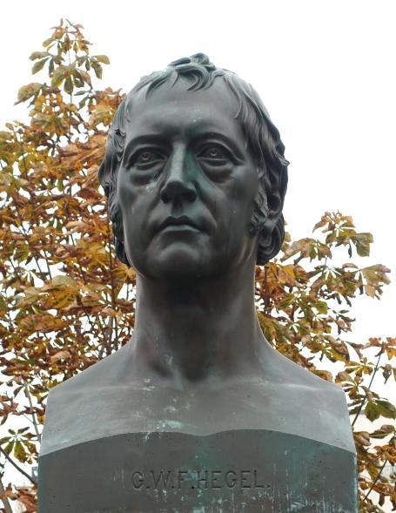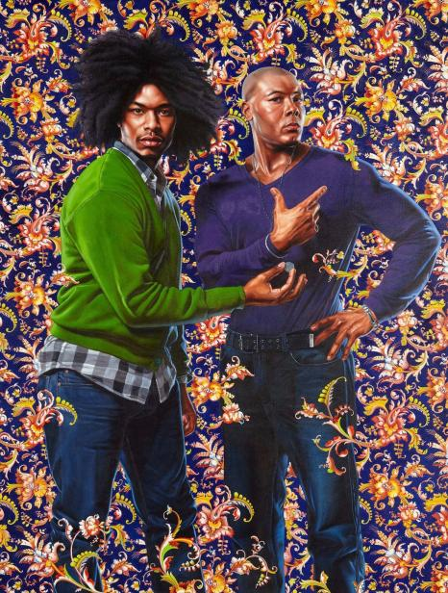
Gustav Blaeser Kehinde Wiley

Aimé “Césaire understood that the truly productive, ‘universal’ experience of reading Hegel is not through a summary of the total and totalizing system, but through the liberation that one’s own imagination can achieve by encountering dialectical thinking in its most concrete exemplification. -Susan Buck-Morss

OVERVIEW
This course enacts a dialectical parallel reading of G.W.F. Hegel’s Phenomenology of Spirit and important moments in the history of Black American Thought. While Hegel is one of the most influential philosophers in western history (comparable to Plato or Descartes), he is rarely placed into dialogue with any black or African-American voices, thus leaving implicit the whiteness of his thought. This class will change that.

This dialectical parallel struck me while participating in a faculty reading group on the history of Critical Race Theory. As we read, the movement between the Black writings echoed the movement in Ch. 4 of Hegel’s Phenomenology. Eventually, the parallel was undeniable, and I felt the need to write a book on it. Yet as a white man, I could not do this alone. Fortunately, I met a brilliant philosopher named Biko Mandela Gray (an expert in Critical Race Theory and philosopher of religion teaching are Syracuse University) who agreed to co-write the book with me. In our discussions, it became clear that this would be an excellent topic for an Elon Senior Seminar in philosophy, with Biko as the next speaker in the Reynold’s lecture series. Hence, this course. Like the eventual book, this course follows a dialectical parallel between Hegel’s highly theoretical text and the philosophical writings of black American authors. This is our textual path:

Hegel’s Phenomenology Black Thought
1) “Master/Slave Dialectic” Frederick Douglass, My Bondage, My Freedom
2) “Stoicism” Booker T. Washington, Up From Slavery
3) “Skepticism” W.E.B. Du Bois, The Souls of Black Folk
4) “Unhappy Consciousness”
a) Devotion The Huey P. Newton Reader
b) Sacramental Work Martin Luther King, Jr., Why We Can’t Wait
c) Self-Mortification The Autobiography of Malcolm X

As we will see, placing these two philosophical movements side-by-side makes idea-sparks fly because the degree to which the unfolding of Hegel’s text corresponds to the movement in black thought is astounding. Much of this course aims to understand Hegel’s abstruse writings and to see how they appear in the black thinkers I have selected to correspond with them, and how the black thinkers spread Hegelian thought further than Hegel himself ever did or could. Yet through this there will be an underlying claim. To see it, step back and consider the social-political conditions of this “placing in parallel.”

On the face of it, it looks like this class uses the high theory of a 19th-century white philosopher to bring conceptual cohesion to the movement of black thought, the implication of which is that the black authors require the help of a white man. If this were so, we would be staring in the face of racism. But there is another side to this dialectical parallelism, one that is distinctly anti-racist because it will contribute to the recent reconsideration of the history of philosophy through questions of race. Here’s how.

As any reading of western philosophy will reveal, white men write nearly all of it; many of those men were implicitly or even explicitly racist (not to overlook the issue of anachronistically applying the category ‘racist’). As philosophers devoted to racial justice through teaching philosophy, the Elon Philosophy Department takes it as an imperative to address philosophy’s racist past whenever possible, and this class meets that imperative face-on. Here is how: Rather than simply submitting the history of black thought to a white philosopher, we make two interconnected claims. First, placing Hegel’s Phenomenology of Spirit in dialogue with Frederick Douglass, W.E.B. Du Bois, Malcolm X, etc. puts those black thinkers directly into the history of philosophy so that they can be considered true philosophers, on par with Plato, Hegel, Foucault, etc. Second (perhaps more importantly), this dialectical parallelism will reveal the whiteness of Hegelianism. Most defenders of philosophy are reluctant to grapple with the racial, it nor racist, dimensions of its history. For example, Charles Mills shows in his remarkable essay “Kant’s Untermenschen” that contemporary Kantians are quite reluctant to consider what it would mean to “see Kant as one of the founders of modern ‘scientific’ racism.” One of the main reasons for this is that it forces devotees of that Konigsberg great to reconsider Kant’s status in the canon. What does it say for the quality of Kant’s thought, we might ask, if racism undergirds or surrounds it all? We, however, are not Hegelian apologists. We will not defend Hegel from racism because we see the whiteness of Hegel very clearly. Thus perhaps the main goal of the course is: The insistence on revealing the whiteness woven through the dialectical movement of his Phenomenology of Spirit. To reach this goal, we will track the six moments of the Phenomenology’s “Chapter 4” alongside the corresponding six moments in the history of black thought. In addition to close reading and focused journaling, students will write semester-long research papers that are based on the model of this dialectical parallel unfolding. On top of that, I, the teacher, will write a professional philosophy paper alongside the students. With an eye toward the book that Biko and I will eventually co-write, this semester we will co-write an essay that we were invited to submit to a forthcoming volume dedicated to the work of George Yancy.
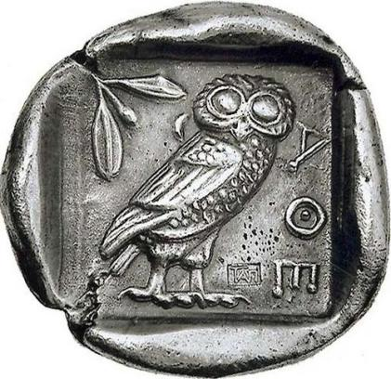

Learning Goals
- Read, understanding, and applying the philosophical content and argumentation of Hegel’s Phenomenology, which might be the most difficult text in the history of philosophy
- Using the “writing to learn” process, rather than merely defend one’s prior views
  - Learning objectives:
    - Can cite (what is required and how to do it)
    - Can use feedback on their work to improve the work (from peers and instructors)
    - Can provide useful and appropriate feedback to peers
- Appreciating the complex nature of the philosophical canon, especially in matters of race and diversity, and identify ways to address the lack of diversity in the history of western philosophy

ASSIGNMENTS

Required Texts (You must acquire these editions)
Frederick Douglass, Autobiographies: Narrative of the Life of Frederick Douglass, an American Slave/My and My Freedom/Life and Times of Frederick Douglass (Library of America, 1994 – ISBN-10: 0940450798)
W.E.B. Du Bois, The Souls of Black Folk: With The Talented Tenth and The Souls of White Folk (Penguin, 1996 – ISBN-10: 014018998X)
G.W.F. Hegel, Phenomenology of Spirit, trans. A.V. Miller (Oxford UP, 1977 – ISBN-10: 0198245971)
Martin Luther King, Jr., Why We Can’t Wait (Signet, 2000 – ISBN-10: 0451527534)
Malcolm X, The Autobiography of Malcolm X: As Told to Alex Haley (Ballantine Books, 1992 – ISBN-10: 0345350685)
Huey P. Newton, The Huey P. Newton Reader (Seven Stories Press, 2002 – ISBN-10: 158322467X)
Booker T. Washington, Up From Slavery (Dover, 1995 – ISBN-10: 0486287386)

Recommended Secondary Sources
Master/Slave & Frederick Douglass
Bernard Boxhill, “The Fight with Covey,” in Existence in Black: An Anthology of Black Existentialist Philosophy, ed. Lewis Gordon (Routledge, 1996), 273-290.
Susan Buck-Morss, Hegel, Haiti, and Universal History (University of Pittsburgh Press, 2009)
Broadus Butler, “Frederick Douglass: The Black Philosopher in the United States: A Commentary,” in Harris, L. (Ed.), Philosophy born of struggle : Anthology of Afro-American philosophy from 1917. (Dubuque, Iowa: Kendall/Hunt Pub.), pp. 1-10
Angela Davis, “Unfinished Lecture on Liberation – II”
Charles W. Mills, “Whose Fourth of July” Frederick Douglass and ‘Original Intent’,” in Charles W. Mills, Blackness Visible: Essays on Philosophy and Race (Cornell, 1998), 167-200.
Mabogo P. More, “Biko Douglass: Existentialist conception of Death,” Philosophia Africana, vol. 17, no. 2 winter 2015/2016 – talks about HEGEL and DOUGLASS!
Cynthia Willett, “Hegel’s Master Narrative of Freedom and the African American Experience” & “A Slave Narrative of Freedom Frederick Douglass and the Force of Manhood,” in Cynthia Willet, Maternal Ethics and Other Slave Moralities (Routledge, 1995) 105-156.

Stoicism & Booker T. Washington and Skepticism & W.E.B. Du Bois
Kwame Anthony Appiah, 1985, “The Uncompleted Argument: Du Bois and the Illusion of Race,” Critical Inquiry 12 (1): 21–37.
Robert Bernasconi, 2009, “W.E.B. Du Bois’s Philosophy of History in Context.” South Atlantic Quarterly, 108 (3): 519–540Tommy L. Lott, 1992–93, “Du Bois on the Invention of Race,” The Philosophical Forum, XXIV, (1–3): 166–187.
Keith Byerman, “Du Bois and Blackness,” Africana Philosophy, vol. 7, no. 1, March 2004, 3-14
Ella Myers, 2017, “Beyond the Wages of Whiteness: Du Bois on the Irrationality of Antiblack Racism,” Items, Social Science Research Council. [http://items.ssrc.org/beyond-the-wages-of-whiteness-du-bois-on-the-irrationality-of-antiblack-racism/]
David S. Owen, “Whiteness in Du Bois’s The Souls of Black Folk,” Africana Philosophy, vol. 10, no. 2, August 2008, 107-126
John P. Pittman, “Double Consciousness”, The Stanford Encyclopedia of Philosophy (Summer 2016 Edition), Edward N. Zalta (ed.), URL = <https://plato.stanford.edu/archives/sum2016/entries/double-consciousness/>.
Stephanie Shaw, 2013, W.E.B. Du Bois and The Souls of Black Folk, Chapel Hill: The University of North Carolina Press.
Ronald Sundstrom, 2003, “Douglass and Du Bois’s Der Schwarze Volksgeist,” in Race and Racism in Continental Philosophy, ed. Robert Bernasconi, Indiana: Indiana University Press, pp. 32–52.
Paul C. Taylor,, 2000, “Appiah’s Uncompleted Argument: W.E.B. Du Bois and the Reality of Race,” Social Theory and Practice 26, 1: 103–128.
Paul C. Taylor, 2004a, “What’s the Use of Calling Du Bois a Pragmatist?,” Metaphilosophy, 35 (1/2): 99–114.
Shamoon Zamir, 1995, Dark Voices, W.E.B Du Bois and American Thought, 1888–1903, Chicago: University of Chicago Press.

Unhappy Consciousness and Huey P. Newton, MLK, Jr., and Malcolm X
Joshua Anderson, “A Tension in the Political Thought of Huey P. Newton,” Journal of African American Studies, Vol. 16, No. 2 (June 2012), pp. 249-267.
J. Herman Blake, “The Caged Panther: the Prison Years of Huey P. Newton,” Journal or African American Studies, Vol. 16, No. 2 (June 2012), pp. 236-248.
Howard Caygill, “Philosophy and the Black Panthers,” Radical Philospohy 179, May/June 2013, https://www.radicalphilosophy.com/article/philosophy-and-the-black-panthers
Huey P. Newton, Revolutionary Suicide (Penguin Classics, 2009)
Hugh Pearson, The Shadow of the Panther: Huey Newton and the Price of Black Power in America, Perseus
Reiland Rabaka,” Malcolm X and/as Critical Theory: Philosophy, Radical Politics, and the African American Search for Social Justice, ”Journal of Black Studies, Vol. 33, No. 2, 13th Cheikh Anta Diop Conference Selected Proceedings (Nov., 2002), pp. 145-165
Cornell West, “The Religious Foundations of the Thought of Martin Luther Kind, Jr.” in We Shall Overcome: Martin Luther King and the Black Freedom Struggle, ed. Peter J. Albert and Ronald Hoffman (New York: Pantheon, 1990).

Other Resources
Robert Bernasconi, especially “Hegel at the Court of Ashanti”, in Stuart Barnett, ed. Hegel After Derrida (New York: Routledge, 1998), 41-63
Robert Bernasconi, “Hegel’s Racism: A Reply to McCarney”, Radical Philosophy, 119 (May/June 2003), 35-37.
Emmanuel Chukwudi Eze, “Georg Wilhelm Friedrich Hegel, ‘Geographical Basis of World History,” in Emmanuel Chukwudi Eze, Race and the Enlightenment: A Reader (Wiley-Blackwell, 1997), 110-149.
Sander L. Gilman, On Blackness without Blacks: Essays on the Image of the Black In Germany (Boston: G.K. Hall and Co., 1982), 93-102.” (on the presence of anti-Blackness in Hegel’s account of art)
Jane Anna Gordon calls ‘creolizing theory’, cf. Creolizing Political Theory: Reading Rousseau through Fanon (New York: Fordham University Press, 2014).
Saidiya V. Hartman, Scenes of Subjection: Terror, Slavery, and Self-Making in Nineteenth-Century America (Oxford UP, 1997)
Achille Mbembe, Critique of Black Reason (Duke UP, 2017)
Charles W. Mills, Blackness Visible: Essays on Philosophy and Race (Cornell, 1998)
John P. Pittman (”’Y’all Niggaz Better Recognize’: Hip Hop’s Dialectical Struggle for Recognition”, in Hip Hop & Philosophy: Rhyme 2 Reason, ed. Derrick Darby and Tommie Shelby, foreword by Cornel West (Chicago and la Salle: Open Court, 2005), 41-53) (seeks to use Hegel’s infamous account of the struggle for recognition to explain the role of battles and ‘beef’ in the music; this view is also briefly forwarded by Eric Michael Dyson, Know What I Mean?: Reflections on Hip Hop (Philadelphia: Basic Civitas Books, 2007), 24.)
Tsenay Serequeberhan, Existence and Heritage: Hermeneutic Explorations in African and Continental Philosophy (SUNY Press, 2015)
Andrew Valls (ed.), Race and Racism in Modern Philosophy, (Cornell UP, 2005); especially “Michael H. Hoffheimer, “Race and Law in Hegel’s Philosophy of Religion,” 194-216.
Jim Vernon, Hip Hop, Hegel, and the Art of Emancipation: Let's Get Free (Palgrave Macmillan, 2018)
Jim Vernon, “Why We Fight: Hegel’s Struggle For Recognition Revisited”, Cosmos and History: The Journal of Natural and Social Philosophy 9:2 (2013), 178-197
Jim Vernon, “Siding with Freedom: Towards a Prescriptive Hegelianism”, Critical Horizons 12:1 (2011), 49-69.”
Calvin L. Warren, Ontological Terror: Blackness, Nihilism, and Emancipation (Duke UP, 2018).

Other Dialectics
The Republic’s “Allegory of cave” and Du Bois’ “Coming of John”
Dostoyevsky’ “Underground Man” with Ralph Ellison’s Invisible Man, Du Bois’ “The Comet,” and Richard Wright’s Man Who Lived Underground

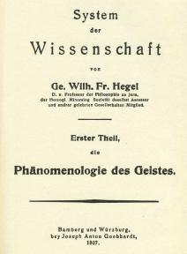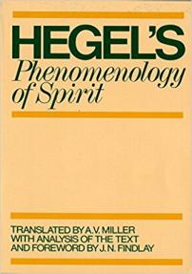

ASSIGNMENTS

1) Participation and Attendance (20% of grade or 20 points)
This is a small class. Most days, there will only be six of us, so we will know each other very well and every absence will be felt clearly. If you miss class, the whole group will be affected. Moreover, the success of each class period depends not only on attendance but also on passionate participation. Everyone must read well before each class. By “read well,” I mean devote a great deal of time, energy, and precision to each reading. This is the most advanced philosophy class at Elon, and you are Elon’s most advanced philosophy students right now. So, plan your reading in advance so that you can read like professional philosophers. I must offer this warning: these are very challenging texts, and you will be constantly frustrated. You will spend many hours each week reading closely and intensely, yet I feel justified in asking this of you because the struggle is worth it. I thus ask each student to fully prepare for each and every class period, with the possible exception of two classes. Each student starts off with two unexcused absences. For any two days this semester (except for major days), you may either skip or not prepare. This can only happen twice. For every missed class period beyond two, if you are absent (without official, proper excuse), unprepared, or disengaged, you will lose 50n points off a possible 100 points for the class. Also, if you miss the conference or any of the special days, you will fail the class.

2) Rumination Journal (30% of grade or 300 points)
You must write one journal entry (min. one page) per class, following this format:

- Select a passage that is relevant to your project
  - While reading our texts, try to remain sensitive to those elements of these philosophies that speak to your project. Gather them together and then copy down the one or two passages into your journal, including a citation (page number, author, title), that truly strike your interest, passion, curiosity, anger, etc.
- Next, ruminate on the passage
  - Let’s strive to practice reading as a kind of slow and careful eating: reading as rumination. Etymologically, to ‘ruminate’ means “to chew the cud.” Cud is a portion of food that returns from a chewers stomach to the mouth in order to be chewed a second time. Like chewing on a cud, I ask you to “chew” on a passage until it becomes soft enough for you to swallow and digest. Record this process in writing.
- Finally, formulate insights
  - Once you have ‘chewed on’ a poignant passage for a while, you should distill your ruminations into precise, sophisticated, and insightful bites. Give the class a taste of the delicious morsels you cooked up. Impress us with your high-level thinking. Sometimes you will want to zoom in on the details of a single concept or phrase (we might call this “analysis”), other times you will want to zoom out and gather together large sets of concepts (we could call this “synthesis”). But always produce at least one insightful, informed, philosophically interesting question that you can share with our class.

Each of these journal entries must be printed out on a piece of paper (typed or free hand) and brought to every class. It is your responsibility – and yours alone – to ensure that you bring a paper copy of your journal to class. It does not count as an excuse to say that a printer was busy or not working. Plan in advance. We meet twice a week. Be sure to get your printing done before class. Do not wait until the last minute before class to print it off. Since your journals are how I will keep attendances, you are allowed only two unexcused skips. Please write down the dates of each of these skips and hand me a piece of paper with your name, the date, and the reading section you are skipping. If you do not bring a hard copy of your completed journal entry, it will count as an absence, and if you miss class for an unexcused and undocumented reason, you cannot submit your journal. Unless something changes, there are 22 ruminations this semester, since you are allowed to miss two, you must do a minimum of 20 ruminations this semester. You will be deducted 25 points for every missed rumination beyond that.

3) Research Paper (50% of grade or 500 points)
The main task of this seminar is to write a formal research paper according to the standards of professional philosophy. This paper, however, will be slightly different than the standard paper because each student will attempt to write in the style of Hegelian thinking. Rather than the usual philosophical argumentative paper, in which a single argument is proffered or a single concept analyzed, Hegelian thinking attunes us to the unfolding of a concept through several stages of its development. To do this, students will select a single concept and track it as it unfolds through the six stages of its development in Ch. 4 of the Phenomenology. Each stage restricts itself to what is going on in that stage alone, or insofar as that stage refers to previous stages. Do not infer or extrapolate beyond that stage. In addition, as we will read Black philosophers who write on themes and topics that correspond to that stage, students should use the Black philosophers’ writings to further explore, critique, or expand the Hegelian version of the concept. More than just exemplifying Hegel’s concept, students should attune to the ways in which race might factor into the concept even though Hegel ignores or overlooks it.

As each stage, evaluation will occur according to several factors:
- How well have you demonstrated an understanding of how Hegel is using the selected concept in the Phenomenology, especially insofar as it operates in the whole argumentative context of the text?
  - We might think of this as translating from the overly abstract and technical language in the Phenomenology, which we might call “Hegelese,” into more easily understandable English, and the ability to go back in the other direction. In short, to move from Hegelese to ordinary language and back to Hegelese.
- How well have you applied this Hegelian concept to the writings of a black author, and justified this application?
  - Ensure that the selected Hegelian concept convincingly appears in the black author
- (3) How well have you used the black authors’ writing to concretize, evaluate, and assess Hegel’s account of the concept?
  - Flesh out Hegel’s concepts, claims, and arguments through the writings of the black authors.
- (4) Have you shown something new about Hegel’s concept that was not clear from reading the Phenomenology alone but that only appeared by applying it to the writings of our class’ black authors? (50 points or 5% of the grade.)
  - Finally, return to Hegel in order to assess his claims and arguments from the perspective of a black American author

The Unfolding of the Concept (If you fail to submit any stage of this paper, you will lose all points of that stage.)

Stage 1: Concept Selection (One paragraph) Students select a single concept from what we have read of Hegel’s Phenomenology, with the aim of connecting it to one of the Black philosophers we engage in this class. Students will identify this concept by name, locate in Hegel, and offer reasonings as to why this concept was selected. As for my (and Biko’s essay), we will write on the general dialectic that runs through each of the six stages. (50 points or 5% of the grade.) DUE: Sept. 5

Stage 2: Master/Slave & Douglass (2-3 pages) Having read Hegel’s account of “Lordship and Bondage” alongside The Narrative of the Life of Frederick Douglass, students will write a philosophical account of their selected concept, with the aim of discovering what happens when the abstract nature of Hegel’s account is placed in the body of a freed slave and related concerns. (50 points or 5% of the grade.) DUE: Sept. 12

Stage 3: Stoicism & Washington (2-3 pages) Having read Hegel’s account of “Stoicism” alongside parts of Booker T. Washington’s Up From Slavery, students will write a philosophical account of their selected concept, with the aim of discovering what happens when the abstract nature of Hegel’s account is placed in the idealism of Washington’s calls for black progress through education and entrepreneurship, rather than direct challenges to racial segregation and disenfranchisement. (50 points or 5% of the grade.) DUE: Sept. 24

Stage 4: Skepticism & Du Bois (2-3 pages) Having read Hegel’s account of “Skepticism” alongside parts of W.E.B. Du Bois’ The Souls of Black Folk, students will write a philosophical account of their selected concept, with the aim of discovering what happens when the abstract nature of Hegel’s account is placed in Du Bois’ sociological critiques of Washington’s idealism through concepts such as “double consciousness.” (50 points or 5% of the grade.) DUE: Oct. 10

Stage 5: “Unhappy Consciousness: Devotion” & Newton (2-3 pages) Having read Hegel’s account of the “Devotion” section of “Unhappy consciousness and parts of The Huey P. Newton Reader, students will write a philosophical account of their selected concept, with the aim of discovering what happens when Hegel’s abstract account is placed in Newton’s writings on the philosophy of the Black Panther party and the emergence of black faith—not necessarily black Christian faith, but black faith in the possibility of freedom made possible both within and from without the system. (50 points or 5% of the grade.) DUE: Oct. 22

Stage 6: “Unhappy Consciousness: Sacramental Work” & MLK (2-3 pages) Having read Hegel’s account of the “Devotion” section of “Unhappy Consciousness” alongside parts of King’s Why We Can’t Wait, students will write a philosophical account of their selected concept, with the aim of discovering what happens when Hegel’s account seen through King’s claims about the nonviolent movement against racial segregation, starting with the “Letter from Birmingham Jail.” (50 points or 5% of the grade.) DUE: Nov. 5

Stage 7: “Unhappy Consciousness: Self-Mortification” & Malcolm X (2-3 pages) Having read Hegel’s account of the “Sacramental Work” section of “Unhappy Consciousness” alongside parts of The Autobiography of Malcolm X, students will write a philosophical account of their selected concept, with the aim of discovering what happens when Hegel’s account is placed in Malcolm X’s claims about black pride, black nationalism, and pan-Africanism. (50 points or 5% of the grade.) DUE: Dec. 3

Stage 8: Final Paper (14-21 pages) Having tracked a single concept as it unfolds through these six stages in Hegel’s Phenomenology and as it is expressed in each of the six Black philosophers we read, students and teacher will return to the beginning and refine their respective papers into a single dialectical development of a concept. This requires re-working each stage so that the transitions at each stage are clear, well explained, and justified. Students must include a one-page introduction and a one-page conclusion that encloses the paper and addresses how this dialectical reading of Hegel and black thought revealed the whiteness of Hegelianism. (150 points or 15% of the grade.) DUE: Dec. 10

Nota bene: Philosophy is, in large part, about thinking, so grading philosophical work, the kind of work you will do in this class, is about assessing the quality of your thinking. Students often erroneously think that philosophy is just a matter of opinion giving. This is wrong. Philosophy is about thinking. Depending on the quality of thinking, philosophy is can be judged to be better or worse. Overall, we can judge the quality of thinking by means of arguments and analysis. High quality thinking (good philosophy) contains convincing arguments and careful, focused, and precise analysis; low quality thinking (poor philosophy) contains unconvincing and careless, unfocused, imprecise analysis. Good philosophy is not just a matter of effort; it is a matter of skill, aptitude, and ability. In sum, your grade will be based on the quality of your thinking.

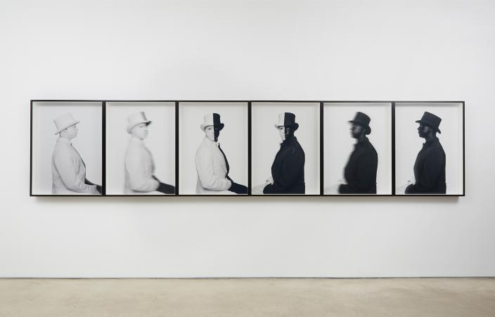
Hank Willis Thomas
Two Conferences
We will have two conferences, which correspond to both of Biko’s visits (First: Oct. 3rd/4th; second: Nov. 30th) to campus. Students are required to perform different tasks at the each conference.

First Conference: At nearly five weeks into the semester, each student will present a well-articulated abstract of his or her concept insofar as it operates in Hegel and in Douglass, Washington, and Du Bois (or the first three stages of the paper) at an in-class conference. With thirty minutes five students, and a thirty minutes reserved for overall discussion, this conference will last around 3 hours. We will together decide the exact time, but it will be either on the evening of the Oct. 3rd or morning/afternoon of Oct. 4th. The presentations should be prepared to be nearly exactly 10 minutes; the subsequent 20 minutes is planned for discussion. Students should tell the audience about the questions, concerns, and issues that they are having while thinking about and writing the paper, as well as what they foresee might happen at future stages. Biko will be present to offer his expertise and professional feedback on each paper, and anyone else interested is invited to attend.

Second Conference: At the end of the penultimate week of classes, Biko will return to Elon in order see how papers have progressed and help bring the paper-writing to a close. To do this we will have a second conference, this time a more formalized and public event. Students must prepare 15-minute formal presentations of their respective research papers. Additionally, students are required to consult with one other member of the philosophy department. Before the first conference on Oct. 3rd/4th, you must contact the faculty member with whom you wish to work and receive written confirmation that this faculty member has agreed to serve a your outside reader. This other philosopher will must be able to perform the following roles:
- Attend both conferences and comment on your paper.
- Be available to help formulate a topic, write early drafts, and think through the issues involved, and consult with through the revision process (other than an initial meeting, this is all up to you to determine how this will proceed);
- This philosopher must read the paper you plan to present at the second conference, and will consult with me as I make the determination that your paper is “philosophically significant and informed”;
- This philosopher will consult with me as I determine the final grade for your paper.

(Nota bene: Throughout, while you will be getting help from another member of the department and I will be consulting with person, I, as the instructor of record, am the one who ultimately will determine your grade based on the criteria we discuss in class.)

Reynold’s Lecture
As with every recent Elon Senior Seminar in Philosophy, the speaker of this semester’s Ferris Reynolds Lecture in Philosophy corresponds to the theme of the Senior Seminar. The Reynolds Lecture Speaker this year is Biko Mandela Gray, from Syracuse University. This summer Biko and I were invited to submit an essay to an upcoming edited volume that is dedicated to the contemporary philosopher George Yancy (who gave the spring 2016 Reynold’s lecture). Our contribution will map how the paper originated from Dr. Yancy’s Lecture at Elon.

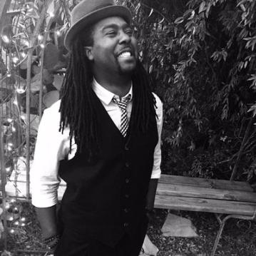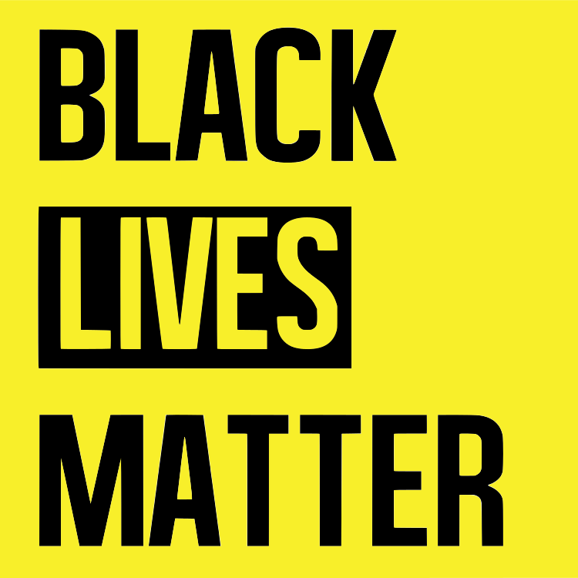

Biko’s talk:
Recent stories of police brutality and anti-black violence (such as the deaths of Tamir Rice, Alton Sterling, Sandra Bland, and others demonstrates) entail philosophical claims about the status of black subjectivity, and the Black Lives Matter movement strives to answer these claims. By engaging these and related philosophical and religious claims at the heart of the Black Lives Matter movement, Biko will interrogate the question as to whether or not matter, as the black body is reduced to, can gain consciousness, and what that means for being a person of color in the America today. Dates of Biko’s trip: Wed. Oct. 3-Sun. Oct. 7. If you miss this event, you will fail the paper, and thus the class, immediately.

Parallel Writing
What is parallel writing? It is an experimental writing pedagogy that I am piloting in this senior seminar. Here is how it goes. While you, the students, write seminar papers, Biko and I will simultaneously write our essay for the above-mentioned edited volume. At each stage of the writing process, we will all share our writing with all the students, inviting comments, questions, critiques, or challenges to our paper. I call this writing pedagogy parallel writing, or writing through parallel play and emulation, on the model of “parallel play” from child pedagogy.

Parallel play is first observed in children aged 2–3,in which children play alongside each other without intentionally trying to influence each other’s behavior. While children are not explicitly playing together, simply because they are in the same space they are implicitly influencing each other, for the children keep what the others are doing in their peripheral vision and modify their play according to what they see the others are doing. The standard image of parallel play is two children playing side-by-side in a sandbox, each absorbed in his or her game, not interacting with the other, but indirectly communicating how they are understanding and grappling with the object in hand. My hunch is that this might be a way to teach writing at university.

This writing pedagogy is different from the normal university means of teaching writing. Normally, students experience the writing process alone. It is only later, when the writing is completely finished, that students submit final versions of the paper to the teacher, who then judges the product without much or (any!) attention paid to the process of writing. To figure how to write a paper, then, students focus on nearly exclusively finished works of philosophy – scholarly articles, classic texts, etc. – and are supposed to divine how to produce such a product themselves. By focusing on the product alone, students ignore the whole process of production. Yet this is precisely the most important part in learning how to write a philosophy paper, or any refined object. Compare it to learning how to sculpt. If one just looked at a finished sculpture, say, the Venus de Milo, and tried to figure out how do the same thing, it would be extremely challenging. But if a sculpture apprentice could follow a master sculptor through the process of producing a sculpture, from acquiring the first raw stone to the polished and finished form, then the apprentice can truly begin to learn how to the same activity, and if the master sculpture and the apprentice work alongside each other, both working on their own raw stone but with the apprentice keeping eye on what the sculptor is doing and modifying her behavior accordingly, then learning to sculpt occurs much more efficiently and effectively. Similarly, the senior seminar students, my apprentices, go through the process of writing a Hegelian philosophy paper alongside me as I go through the same process. From the first step – taking up the assigned task of writing this paper – to the last – the final, finished paper – students undertake a true philosophical apprenticeship. From my experience, students and teachers rarely both write simultaneously, in parallel, on the same topic. The goal is for students to vividly understand the concrete challenges involved in writing like professional philosophers.

Grade calculation table: The total possible points for this class is 1000 points.

Assignment Possible Points Your points
Paper Stage 1 | 50
Paper Stage 2 | 50
Paper Stage 3 | 50
Paper Stage 4 | 50
Paper Stage 5 | 50
Paper Stage 6 | 50
Paper Stage 7 | 50
Paper Stage 8 | 150
Journals | 300
Participation | 200
Total | 1000

Grade Scale : A = 92% to100% A- = 90% to 91%
B+ = 88% to 89% B = 82% to 87% B- = 80% to 81%
C+ = 78% to 79% C = 72% to 77% C- = 70% to 71%
D+ = 68% to 69% D = 60% to 67%

Take your professor to lunch! You are invited to take your professor to lunch (at Colonnades, Lakeside, of McEwan) for free (it is an Elon program). Anytime you me to join you and friends for lunch, let me know. I would love to engage in the practice of eating with you and learn more about each of you.

OTHER EVENTS
- Interaction with Dr. Pearson’s class on Narratives of Slavery. Given the clear resonances and overlap between the two classes, there will be several opportunities for our seminar to interact with Dr. Pearson’s class, starting on September 11th. Since Dr. Pearson and I
- On October 16th, the two people who run the North Carolina Runaway Slave Advertisements database will be coming to Dr. Erin Pearson’s class in order to discuss the project. Dr. Pearson’s plan is to build that visit into a larger discussion about the limited and sometimes problematic channels through which information about enslaved people is often available, and how the work of literature might provide an important imaginative corrective to the limitations of history. Dr. Pearson has invited us to attend and participate in her class. We should think about going.
- Trip to American Civil War Museum in Richmond, VA. Dates TBD (but late in the semester). You are all invited and encouraged to join a field trip to this museum in Richmond (about a 3 hour bus ride from Elon), along with Dr. Pearson’s class and possibly some other classes that are focusing on similar themes. It will be a one-day trip, leaving early in the morning and arriving late in the evening. There will be a minimal fee to join, though this is not required if anyone is unable to cover the cost (just let me know and I will make it happen). Plans are forthcoming.
- On October 25th in the Isabella Cannon Room, 7 p.m. John Biewen, the director of audio documentaries at Duke’s Center for Documentary Studies and producer and host of the Scene on Radio Podcast asks: Just what is going on with white people? Police shootings of unarmed African Americans; acts of domestic terrorism by white supremacists; the renewed embrace of raw, undisguised white-identity politics; unending racial inequity in schools, housing, criminal justice, and hiring. Some of this feels new, but in truth it’s an old story. Why? Where did the notion of “whiteness” come from? What does it mean? What is whiteness for? John Biewen took a deep dive into these questions through his series on the Scene on Radio podcast, “Seeing White.” His talk will feature clips from the series outlining the invention and construction of race as we know it, and exploring the fundamental mistakes we make in thinking about racism — what it is and how it works in the world.

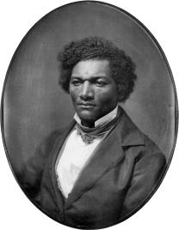
CLASS DIALECTIC

Aug. 29 Syllabus, begin Hegel, “Lordship and Bondage”
Sept. 3 Hegel, “Lordship and Bondage” (§§178-196): Rumination 1
Sept. 5 Douglass, Narrative of the Life (pp. 3-50): Rum. 2
Paper Stage 1 Due
Sept. 10 Douglass (pp. 50-102): Rum. 3

Sept. 11 Visit Dr. Pearson’s class: Narratives of Slavery
(to talk about Hegel’s master-slave dialectic)

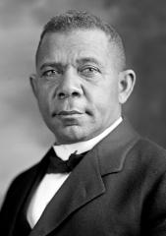
Sept. 12 Hegel, “Stoicism” (§§197-201): Rum. 4
Paper Stage 2 Due
Sept. 17 Washington (pp. 1-63): Rum. 5
Sept. 19 Washington (pp. 64-115): Rum. 6

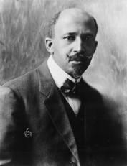
Sept. 24 Hegel, “Skepticism” (§§202-206): Rum. 7
Paper Stage 3 Due
Sept. 26 Du Bois, The Souls of Black Folk (pp. 1-47): Rum. 8
Oct. 1 Du Bois (pp. 48-84): Rum. 9
Oct. 3 Students prepare for Biko’s visit (without Ryan)
Oct. 4 Biko’s talk
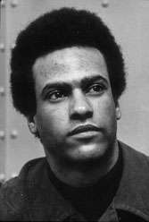
Oct. 8 Du Bois (pp. 85-141): Rum. 9

Oct. 10 Hegel, “U.C.: Devotion” (§§206-217): Rum. 10
Paper Stage 4 Due
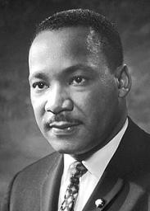
Oct. 15 Huey P. Newton Reader (pp. 25-78): Rum. 11
Oct. 17 Newton (79-130): Rum. 12
Oct. 22 Newton (131-180): Rum. 13
Paper Stage 5 Due

Oct. 24 Hegel, “U.C” (§§218-223): Rum. 14
Oct. 29 MLK, Why We Can’t Wait (pp.1-45): Rum. 15
Oct. 31 MLK (pp. 45-99): Rum. 16
Nov. 5 MLK (pp. 100-143): Rum. 17
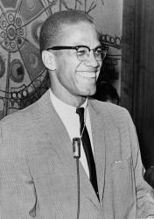
Paper Stage 6 Due

Nov. 7 Hegel, “U.C.: Sacramental Work” (§§224-230): Rum. 18
Nov. 12 The Autobiography of Malcolm X (pp. 1-58): Rum. 19
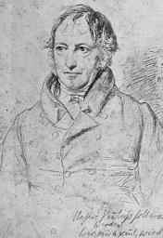
Nov. 14 Malcolm X (pp. 59-110): Rum. 20
Nov. 19-23 Thanksgiving Break

Nov. 26 Malcolm X (pp. 111-153): Rum. 21
Nov. 28 Conference Preparations
Nov. 30 Second Conference (a Friday)

Dec. 3 TBA
Paper Stage 7 Due
Dec. 5 TBA: Rum. 22

Dec. 10 Paper Stage 8 Due
University Policies and Resources
Elon Honor Code
Elon’s honor pledge calls for a commitment to Elon’s shared values of Honesty, Integrity, Respect and Responsibility. To be clear about what constitutes violations of these values; students should be familiar with code of conduct policies in the student handbook, including violations outlined at
http://www.elon.edu/e-web/students/handbook/violations/default.xhtml. Students with questions about the specific interpretation of these values and violations as they relate to this course should contact me immediately. Violations in academic-related areas will be documented in an incident report which will be maintained in the Office of Student Conduct, and may result in a lowering of the course grade and/or failure of the course with an Honor Code F. (In fact, my policy is that any violation of the honor code results in an immediate grade of “F” for the course, RJ.)Violations specifically covered by academic honor code policies include: plagiarism, cheating, lying, stealing and the facilitation of another’s dishonesty. Multiple violations will normally result in a student’s temporary suspension from the University.

Elon Disabilities Services
If you are a student with a documented disability who will require accommodations in this course, please register with Disabilities Services in the Duke Building, Room 108 (278-6500), for assistance in developing a plan to address your academic needs. For more information about Disabilities Services, please visit the website http://www.elon.edu/e-web/academics/support/disabilities_services.xhtml.

Elon Writing Center
Elon’s Writing Center in the Center for Writing Excellence is staffed by trained peer-consultants who can help you with all of your writing projects (for any class or major and for any extracurricular, personal, or professional purposes), so take advantage of this excellent academic resource and include a visit to our Writing Center as part of your own writing process. In one-on-one, 45 minute sessions, our consultants will work with you on any kind of writing (such as research or analysis papers, PowerPoint or poster presentations, resumes, or job applications) at any stage of the writing process (such as understanding an assignment; brainstorming, drafting, revising, and editing; developing a research question or starting your research; or writing in-text citations and bibliographies/works cited). We have two multimedia production studios to create and work with a consultant on your multimedia and visual texts (such as PowerPoint or Prezi presentations, videos, or websites). Visit our presentation practice room where you can easily record and critique yourself giving a presentation and get feedback from a consultant on your accompanying visuals. The main Writing Center in Belk Library is open extensive hours, and also staffs satellite Writing Centers in CREDE and the Business School. If you have questions, please contact The Writing Center Director, Dr. Rosinski at prosinski@elon.edu or X5842.

Religious Holidays Policies
Elon has a policy and procedures for students who wish to observe religious holidays that are in conflict with the academic calendar, allowing students an excused absence. Students who wish to observe a holiday during the semester must complete the online Religious Observance Notification Form (RONF), available at the following website within the first two weeks of the semester. This policy does not apply during the final examination period. Students are required to make prior arrangements with the instructor for completion of any work missed during the absence. Once the completed RONF is received, the Truitt Center will confirm the excused absence with notification to the instructor and the appropriate academic dean, along with a copy to the student. Students may contact the Truitt Center with questions (336-278-7729).

Student Options Related to Enrollment in Your Course
Enrollment: Students should confirm their enrollment in this course through their On-Track account. Students who do not appear on the course roll or do not show the correct course/section listed on On-Track should consult with their instructor immediately.
Policies on Dropping or Withdrawing from this Course
- Students may drop a course during the designated drop/add period through their On-Track account. A course that is dropped during the designated drop/add period will not appear on the student’s transcript or grade report.
- After the designated drop/add period, students may withdraw from a course without penalty through the first half of the semester, following dates published in the academic calendar. Withdrawing from a course during this period will result in a mark of “W” that will appear on the student’s academic transcript. Students may withdraw by using the online process located at http://www.elon.edu/e-web/administration/registrar/DropAddClassesOnline.xhtml
NOTE: Students should not assume that they will be officially withdrawn from a course based on their failing to attend class or their notifying a faculty member of their intent to withdraw. The student has the responsible for following the official process of withdrawing from a class. Students who do not properly withdraw from a course will receive a grade of F.
- Students may not withdraw from a course after the deadline. Any exception to this policy is the responsibility of the appropriate academic dean’s office. When granted, withdrawal from a course after this time will result in a grade of “W” or “F” depending on the student’s grade at the time. For additional information on university course policies, students should consult their Academic Catalog: http://www.elon.edu/e-web/academics/catalog/

In Andrew Valls (ed.), Race and Racism in Modern Philosophy. Cornell University Press. pp. 169-93 (2005)

